**Coffee Shop Data Analysis**

**Objective**

The main objective of this project is to analyze retail sales data to gain the actionable insights that will enhance the performance of the coffee shop.

**Recommended Analysis**

* How do sales vary by day of the week and hour of the day?
* Are there any peak times for sales activity?
* What is the total sales revenue for each month?
* How do sales vary across different store locations?
* What is the average price/order per person?
* Which products are the best-selling in terms of quantity and revenue?
* How do sales vary by product category and type?
* Share your work on LinkedIn and tag **@Maven Analytics** for a chance to get your work reviewed and featured by the Maven team!

**Color Palettes**

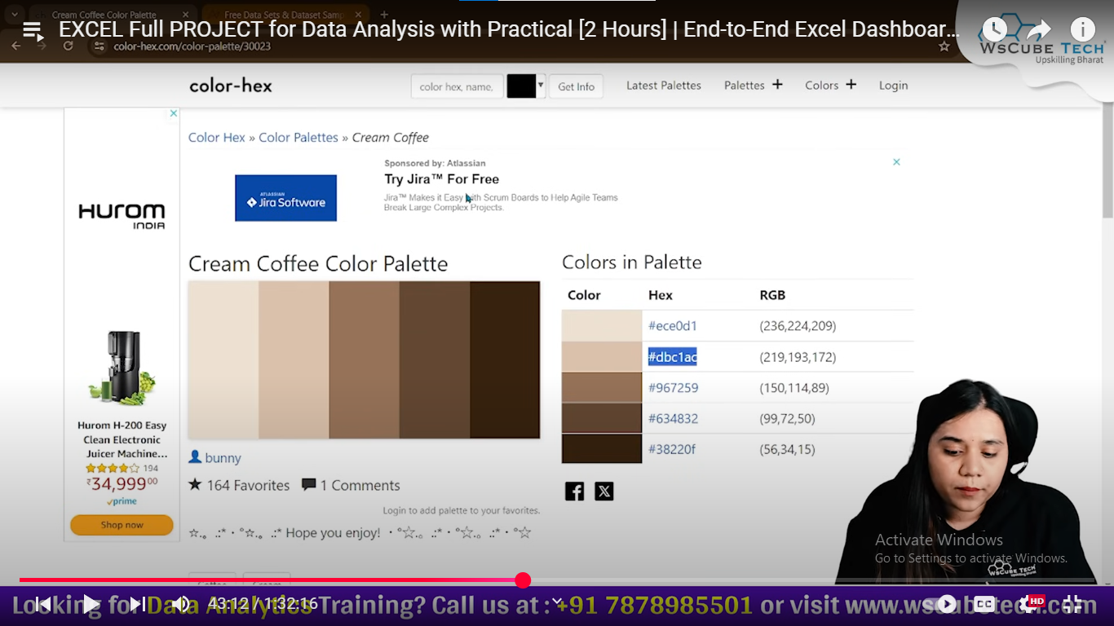

**DAX Measures used**

1. Average_Bill = SUM(Transactions[Total_bill])/COUNT(Transactions[transaction_id])
2. Average_Order = SUM(Transactions[transaction_qty])/DISTINCTCOUNT(Transactions[transaction_id])
3. Foodfall = DISTINCTCOUNT(Transactions[transaction_id])
4. Sales = SUM(Transactions[Total_bill])